
TRIBHUVAN UNIVERSITY
FACULTY OF HUMANITIES AND SOCIAL SCIENCE

A Project Report
On
Ticketflow: Complaint Management System
Submitted to
Department of IT
Hetauda School of Management and Social Sciences
In partial fulfillment of the requirements for the degree of Bachelor in Computer Application
Submitted By:
Prajwal Lamichhane
Under the Supervision of
Pratikshya gartaula

Tribhuvan University
Faculty of Humanities and Social Sciences
Hetauda School of Management and Social Sciences
Ticketflow: Complaint Management System
A Project Report Submitted to the Department of IT in partial fulfillment of the requirements for the degree of Bachelor in Computer Application
Submitted By:
Prajwal Lamichhane
Supervisor:
Pratikshya Gartaula
Supervisor's Recommendation
I hereby recommend that this project prepared under my supervision by Prajwal Lamichhane entitled "Ticketflow: Complaint Management System" in partial fulfillment of the requirements for the degree of Bachelor of Computer Application is recommended for the final evaluation.

Sincerely,
........................................
Pratikshya Gartaula
Supervisor
Hetauda School of Management and Social Sciences, Hetauda
Approval Letter
This is to certify that the project work entitled "Ticketflow: Complaint Management System" has been prepared by Prajwal Lamichhane of Bachelor of Computer Application (BCA) at the Faculty of Humanities and Social Sciences, Department of IT, Hetauda School of Management and Social Sciences, and has been approved by the undersigned evaluation committee.

..........................................
(Head of Department)
Er. Sujan Devkota
Department of IT
Hetauda School of Management and Social Sciences

..........................................
(External Examiner)
Declaration
I, Prajwal Lamichhane, hereby declare that this project, titled "Ticketflow: Complaint Management System", and the work presented in it are my original contributions, except where otherwise indicated. I have acknowledged all sources used in this project report, and I have cited all sources from which I have used data, ideas, or words, whether quoted directly or paraphrased. This project has not been previously submitted for any degree or examination at any other university or institution.
Where other people's work has been used (from books, articles, internet sources, or any other sources), it has been duly acknowledged and referenced in the references section.
I further declare that this project is the result of my own independent work. I understand that any act of plagiarism or academic dishonesty will result in serious consequences, including possible disqualification from the degree program.

..........................................
Prajwal Lamichhane
Date: 2026, 5 October
Acknowledgement
I would like to express my sincere gratitude to everyone who supported me during the development of the project "Ticketflow: Complaint Management System".
First, I would like to thank my supervisor, Laxman Gautam, for his guidance, encouragement, and constructive feedback throughout the project. His suggestions helped me to improve both the system and this report.
I am also grateful to the Department of IT and the faculty members of Hetauda School of Management and Social Sciences for providing the academic environment and the knowledge required to complete this work. I extend my appreciation to the Head of Department, Er. Sujan Devkota, for his support.
I would also like to thank my family and friends for their continuous encouragement and for testing the system and sharing their opinions during development. This project has been a valuable learning experience in web development, database design, and software documentation.

Prajwal Lamichhane
Abstract
Handling complaints and support requests through telephone calls, verbal messages, or scattered e-mails makes it difficult to record, assign, and follow them until they are resolved. "Ticketflow: Complaint Management System" is a web-based application developed to provide a single, organized platform for submitting, assigning, tracking, and resolving complaints in the form of tickets.
The system is developed using HTML, CSS, and JavaScript for the front end, and PHP with a MySQL database for the back end, and it is run on an Apache server (XAMPP) during development. It supports three roles. Registered users can create tickets with a subject, category, priority, description, and an optional attachment, track the status of their tickets, and reply to them. Support staff can view the tickets assigned to them, filter them, update their status, and respond to users. Administrators can manage users, categories, and all tickets, assign tickets to staff, view recent activity in an audit trail, and review a reporting page with filters and a CSV export. A notification indicator and a light/dark display mode are also provided.
The interface screenshots included in this report show the implemented user, staff, and administrator screens. The project demonstrates how a PHP and MySQL web application can be used to make complaint handling more transparent, traceable, and organized within an institution.
Keywords: PHP, MySQL, Complaint Management System, Ticket Management, Role-Based Access, User Management, Web Application.
Table of Contents
CHAPTER 1: INTRODUCTION 1
1.1 Background 1
1.2 Problem Statement 1
1.3 Aim and Objectives 1
1.4 Scope and Limitations 2
1.4.1 Scope 2
1.4.2 Limitations 2
1.5 Significance of the Project 2
1.6 Report Organization 3
CHAPTER 2: BACKGROUND STUDY AND LITERATURE REVIEW 4
2.1 Background Study 4
2.2 Existing Approaches to Complaint Handling 4
2.3 Limitations of Informal Approaches 4
2.4 Proposed System 5
2.5 Summary 5
CHAPTER 3: SYSTEM ANALYSIS AND DESIGN 6
3.1 System Design Methodology 6
3.2 Requirement Analysis 6
3.2.1 Functional Requirements 6
3.2.2 Non-Functional Requirements 7
3.3 Feasibility Study 7
3.3.1 Technical Feasibility 7
3.3.2 Operational Feasibility 7
3.3.3 Economic Feasibility 8
3.3.4 Schedule Feasibility 8
3.4 Gantt Chart 8
3.5 System Architecture 8
3.6 Use Case Diagram 9
3.7 Use Case Description 10
3.8 Data Flow Diagrams 11
3.8.1 Context-Level DFD (Level 0) 11
3.8.2 Level 1 DFD 12
3.9 Entity Relationship Diagram 13
3.10 Database Design 14
3.11 System Flowchart 16
3.12 Ticket Status Lifecycle 16
CHAPTER 4: SYSTEM IMPLEMENTATION 17
4.1 Implementation Overview 17
4.2 Development Environment 17
4.3 Technologies Used 17
4.4 Front-End Implementation 17
4.5 Back-End Implementation 18
4.6 Database Implementation 18
4.7 Authentication and Authorization 18
4.8 User Module 18
4.9 Staff Module 18
4.10 Administrator Module 18
4.11 Ticket Management 19
4.12 Category Management 19
4.13 Replies and Communication 19
4.14 Notification System 19
4.15 Attachment Handling 19
4.16 Reports and Audit Trail 19
4.17 Display Mode and Responsive Layout 19
CHAPTER 5: SYSTEM TESTING 21
5.1 Introduction 21
5.2 Testing Strategy 21
5.3 Test Environment 21
5.4 Test Cases 21
5.5 Functional Testing 24
5.6 Integration Testing 24
5.7 System Testing 24
5.8 User Acceptance Testing 24
5.9 Test Results 24
5.10 Summary 24
CHAPTER 6: RESULTS AND DISCUSSION 25
6.1 Introduction 25
6.2 Login Interface 25
6.3 User Registration 25
6.4 User Dashboard 26
6.5 Ticket Creation 27
6.6 Staff Dashboard 27
6.7 Assigned Tickets 28
6.8 Administrator Dashboard 28
6.9 User Management 29
6.10 Reporting and Analytics 30
6.11 Discussion of Results 30
CHAPTER 7: CONCLUSION AND FUTURE ENHANCEMENTS 32
7.1 Lessons Learnt 32
7.2 Conclusion 32
7.3 Future Enhancements 32
REFERENCES 33
APPENDIX A: SUPERVISOR LOG SHEET 34

List of Figures
Figure 1: Iterative Development Stages Followed in the Project 6
Figure 2: System Architecture of Ticketflow 9
Figure 3: Use Case Diagram of Ticketflow 10
Figure 4: Context-Level DFD (Level 0) of Ticketflow 12
Figure 5: Level 1 DFD of Ticketflow 13
Figure 6: Conceptual ER Diagram of Ticketflow 14
Figure 7: System Flowchart of Ticketflow 16
Figure 8: Ticket Status Lifecycle 16
Figure 9: Login Interface 25
Figure 10: User Registration Interface 26
Figure 11: User Dashboard 26
Figure 12: Ticket Creation Interface 27
Figure 13: Support Staff Dashboard 27
Figure 14: Assigned Tickets Interface of Support Staff 28
Figure 15: Administrator Dashboard 29
Figure 16: User Management Interface of Administrator 29
Figure 17: Reporting and Analytics Interface 30

List of Tables
Table 1: Comparison of Informal Handling and the Proposed System 5
Table 2: Planned Project Schedule (Gantt Chart) 8
Table 3: Use Case Description: Create Ticket 10
Table 4: Use Case Description: Update Ticket Status 11
Table 5: Use Case Description: Manage Users 11
Table 6: Database Tables and Their Attributes 14
Table 7: Data Dictionary: Users Table 15
Table 8: Data Dictionary: Tickets Table 15
Table 9: Development Environment 17
Table 10: Test Cases: Authentication and Registration 21
Table 11: Test Cases: Ticket Management 22
Table 12: Test Cases: Staff and Administrator Functions 22
Table 13: Integration and System Test Cases 23
Table 14: Summary of Test Results 24
Table 15: Supervisor Log Sheet 34

List of Abbreviations
Abbreviation | Full Form
BCA | Bachelor in Computer Application
CSS | Cascading Style Sheets
CSV | Comma-Separated Values
DFD | Data Flow Diagram
ER | Entity Relationship
HTML | Hyper Text Markup Language
HTTP | Hyper Text Transfer Protocol
ID | Identifier
JS | JavaScript
KPI | Key Performance Indicator
MySQL | My Structured Query Language (relational database management system)
PDO | PHP Data Objects
PHP | PHP: Hypertext Preprocessor
RDBMS | Relational Database Management System
SQL | Structured Query Language
TU | Tribhuvan University
UI | User Interface
UAT | User Acceptance Testing
XAMPP | Cross-platform, Apache, MySQL, PHP, Perl (local server package)

CHAPTER 1: INTRODUCTION

1.1 Background
In every organization, users sometimes face problems that need to be reported and resolved: a technical fault, a hardware issue, a software problem, or a general inquiry. When these complaints are reported verbally, on paper, or through scattered messages, they are easily forgotten, the person responsible is unclear, and the user has no way of knowing whether the problem is being worked on.
Ticketflow: Complaint Management System is a web-based application developed to manage this process in an organized way. A user registers, logs in, and submits a complaint as a ticket. Each ticket receives a ticket number, a category, a priority level (Low, Medium, High, or Urgent), and a status that changes as the ticket is handled. Support staff work on the tickets assigned to them, while an administrator manages the users, categories, and the overall ticket flow and can review reports of the system's activity.
The system is built with HTML, CSS, and JavaScript on the front end and PHP with a MySQL database on the back end. It uses role-based dashboards so that each type of user sees only the functions relevant to that role.

1.2 Problem Statement
Complaint handling that relies on informal channels creates several practical problems:
- Complaints are not stored in one place, so they can be lost or overlooked.
- Users cannot easily see whether their complaint has been received, assigned, or resolved.
- It is unclear which staff member is responsible for a complaint, and the workload of staff members cannot be measured.
- Communication between the user and the responsible person is scattered across different channels, and there is no history of what was said or done.
- Administrators have no summarized view of how many complaints are open, how many are urgent, or how many have been resolved.
A centralized, role-based ticketing system is therefore needed to record every complaint, assign it to a responsible person, keep its history, and report its progress.

1.3 Aim and Objectives
Aim: To develop a web-based complaint management system that allows complaints to be submitted, assigned, tracked, and resolved through a single platform.
The specific objectives of the project are:
- To provide a registration and login facility with separate dashboards for users, support staff, and administrators.
- To allow users to submit complaints as tickets with a category, priority, description, and optional attachment.
- To allow users to track the status of their tickets and reply to them.
- To allow support staff to view, filter, and manage the tickets assigned to them and to update their status.
- To allow administrators to manage users, categories, and tickets and to monitor activity through an audit trail.
- To provide summary reports of tickets by status, priority, category, and staff workload, with a CSV export.

1.4 Scope and Limitations

1.4.1 Scope
The system can be used by three types of people within an organization:
- Users can register, log in, create tickets, view their tickets on a dashboard, edit or delete their tickets, view ticket details, reply, and manage their profile.
- Support staff can view the tickets assigned to them, search and filter them by status, priority, and category, update the ticket status, and respond to users.
- Administrators can view system-wide statistics, view and manage all tickets, add and edit users and assign roles, manage ticket categories, review the recent audit trail, and open the reporting page to filter data and export a CSV file.
In addition, the system supports file attachments on tickets, a notification indicator in the header, ticket numbers for identification, and a light/dark display mode.

1.4.2 Limitations
- The system is a web application that requires a browser and a network connection to a server; it has no separate mobile application.
- Notifications are shown inside the application only; e-mail or SMS notifications are not part of the current system.
- The reporting page provides counts, percentages, and a workload table; it does not include graphical charts or advanced analytics.
- Attachments are limited to the listed file types and to a size of 5 MB per file.
- The system was tested with a small set of sample data and a limited number of users, so large-scale performance has not been evaluated.
- Priority and category are selected manually by the user; they are not classified automatically.

1.5 Significance of the Project
The project replaces informal complaint handling with a structured process in which every complaint has a number, an owner, a status, and a history. Users gain visibility into their complaints, staff gain a clear queue of work, and administrators gain a summarized view of the organization's complaints. The project also gave the developer practical experience in building a role-based web application with PHP and MySQL.

1.6 Report Organization
This report is organized into seven chapters. Chapter 1 introduces the project, its objectives, scope, and limitations. Chapter 2 discusses the background study and related approaches to complaint handling. Chapter 3 presents the system analysis and design, including requirements, feasibility, and the system diagrams. Chapter 4 describes the implementation and the tools used. Chapter 5 covers system testing. Chapter 6 presents the results of the system through its actual interface screenshots with discussion. Chapter 7 gives the conclusion, lessons learnt, and future enhancements. References and appendices follow Chapter 7.

CHAPTER 2: BACKGROUND STUDY AND LITERATURE REVIEW

2.1 Background Study
A complaint or support request is a report from a person that something is not working as expected and needs attention. Organizations that handle such reports commonly use the idea of a "ticket": a record that is created when the problem is reported and that is followed until it is closed. The following concepts are central to this project:
- Ticket: A record of a complaint containing a number, subject, category, priority, description, status, and the people involved.
- Status lifecycle: The stages a ticket passes through. In this system the statuses defined in the database are New, Open, Assigned, In Progress, Resolved, Closed, and Reopened.
- Priority: The urgency of a ticket. In this system the levels are Low, Medium, High, and Urgent.
- Role-based access: Different types of users (User, Staff, Admin) are given different screens and permissions.
- Audit trail: A time-ordered record of actions taken on tickets, such as status changes and replies.

2.2 Existing Approaches to Complaint Handling
Complaints in small and medium organizations are commonly handled in one of the following ways:
- Verbal or paper-based reporting: The user tells a staff member or fills in a paper form. The record depends on the person who receives it.
- E-mail or messaging applications: Complaints are sent as messages. They are easy to send, but they are mixed with other messages and are difficult to assign, count, or follow.
- Dedicated helpdesk or ticketing software: Many ticketing tools are available for organizations. They provide ticket tracking, assignment, and reports, but they may require subscriptions, configuration, or more features than a small institution needs.
Well-known examples of dedicated helpdesk software include Zendesk, Freshdesk, and the open-source osTicket. These products are mentioned only as examples of the category; they were not tested or evaluated as part of this project.

2.3 Limitations of Informal Approaches
The limitations of the informal approaches discussed above are the main reasons for developing this system. They do not keep a complete history of a complaint, they do not show the current status to the user, they do not clearly assign responsibility, and they do not provide any summary of how many complaints are pending or resolved. Table 1 compares these approaches with the proposed system.

2.4 Proposed System
The proposed system, Ticketflow: Complaint Management System, keeps all complaints in a MySQL database and provides role-specific screens. A user creates a ticket and follows it from the dashboard. A staff member works from an assigned-ticket queue. An administrator manages users, categories, and tickets and reviews reports. Every important action, such as a status change or a reply, appears in the audit trail. Table 1 summarizes the comparison.
Table 1: Comparison of Informal Handling and the Proposed System
Aspect | Verbal / paper / e-mail handling | Ticketflow (proposed system)
Recording of complaints | Depends on the person who receives it; may be lost | Stored in a database with a ticket number
Status visibility | User must ask the staff member | Status shown on the user dashboard and ticket list
Assignment | Informal; responsibility is unclear | Tickets show the assigned staff member (or "Unassigned")
Communication | Scattered across channels | Replies are kept with the ticket
History | Not maintained | Recent audit trail of actions on tickets
Summary and reporting | Manual counting | Reports page with filters, workload table, and CSV export

2.5 Summary
Informal complaint handling is simple to start but becomes unreliable as the number of complaints grows. A ticket-based web application solves the main problems by giving every complaint a record, an owner, a status, and a history. The next chapter analyzes the requirements and design of the proposed system.

CHAPTER 3: SYSTEM ANALYSIS AND DESIGN

3.1 System Design Methodology
Several software development models can be used for a web-based system. The Waterfall model follows distinct sequential phases and suits projects with stable requirements. The Incremental model develops the system in separate modules. The Agile model develops the system in short iterations and allows requirements and the interface to be improved with feedback [1]–[3].
The Agile (iterative) approach was followed for this project because the user, staff, and administrator screens could be developed and refined one after another, and the interface could be corrected after each round of testing. The stages followed were requirement planning, design, development, testing, deployment, and review, as shown in Figure 1.
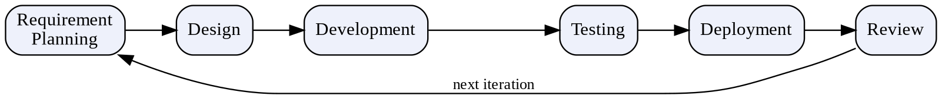
Figure 1: Iterative Development Stages Followed in the Project

3.2 Requirement Analysis
The requirements were derived from the problems described in Chapter 1 and from the functions that a complaint handling process needs. They are divided into functional and non-functional requirements.

3.2.1 Functional Requirements
General
- The system shall allow a person to register with a full name, e-mail address, optional phone number, and password (with confirmation).
- The system shall allow registered persons to log in with e-mail and password and shall open the dashboard that matches their role.
- The system shall provide a profile page, a logout option, and a notification indicator for each role.
User
- The user shall be able to create a ticket by entering a subject, category, priority, and description, with an optional attachment.
- The user shall be able to see the number of total, open/pending, in-progress, and resolved tickets and a list of recent tickets on the dashboard.
- The user shall be able to view, edit, and delete tickets from the list, and view the full list under "My Tickets".
Support Staff
- The staff member shall be able to see counts of new/assigned, in-progress, resolved, and high-priority tickets.
- The staff member shall be able to view assigned tickets and search or filter them by ticket number, subject, client, status, priority, and category.
- The staff member shall be able to open a ticket using the "Manage" action to handle it and update its status.
Administrator
- The administrator shall be able to see system statistics (total tickets, new/open, in progress, urgent/high priority, registered clients, and support agents), recent tickets, and a recent audit trail.
- The administrator shall be able to view all tickets and manage them, including seeing which staff member each ticket is assigned to.
- The administrator shall be able to search, filter, add, and edit users and assign the User, Staff, or Admin role.
- The administrator shall be able to manage ticket categories.
- The administrator shall be able to view reports filtered by time, status, priority, category, and staff, and export them as CSV.

3.2.2 Non-Functional Requirements
- Usability: The interface should be simple and consistent, with a sidebar for navigation, clear status and priority labels, and required fields marked with an asterisk.
- Security and access control: Each role should be able to access only its own screens; password entry should be masked.
- Performance: Pages should load quickly for the expected number of users of a small organization.
- Reliability: Ticket data should be stored permanently in the database and should not be lost between sessions.
- Compatibility: The system should be usable in a standard web browser, and the layout should adapt to different screen sizes.
- Maintainability: The system should be organized in modules so that features can be added later.

3.3 Feasibility Study
A feasibility study examines whether the system can be built under the available conditions.

3.3.1 Technical Feasibility
The system uses HTML, CSS, JavaScript, PHP, and MySQL, which are widely documented and freely available, and it runs on a local Apache server using XAMPP. The developer had the knowledge required to use these technologies, so the project is technically feasible.

3.3.2 Operational Feasibility
The system is accessed through a web browser and uses familiar forms, tables, and buttons. Users, staff, and administrators do not need special training to use it, so it is operationally feasible.

3.3.3 Economic Feasibility
All tools used (XAMPP, PHP, MySQL, a text editor, and a web browser) are free to use for development, so no software purchase was required, and the system is economically feasible.

3.3.4 Schedule Feasibility
The project was planned in phases over ten weeks, as shown in Table 2. Since the modules were developed one after another, the project was feasible within the academic schedule.

3.4 Gantt Chart
A Gantt chart presents project tasks against a timeline. Table 2 shows the planned schedule of the project.
Table 2: Planned Project Schedule (Gantt Chart)
Process / Week | 1 | 2 | 3 | 4 | 5 | 6 | 7 | 8 | 9 | 10
Requirement Gathering
Planning
Designing
Coding
Testing and Debugging
Implementation

3.5 System Architecture
The system follows a three-layer web architecture, shown in Figure 2. The presentation layer is the web browser, which displays the pages written in HTML, CSS, and JavaScript. The application layer consists of PHP scripts running on an Apache server, which handle authentication, ticket management, user and category management, and reporting. The data layer is a MySQL database accessed through PDO, together with server storage for uploaded attachments.
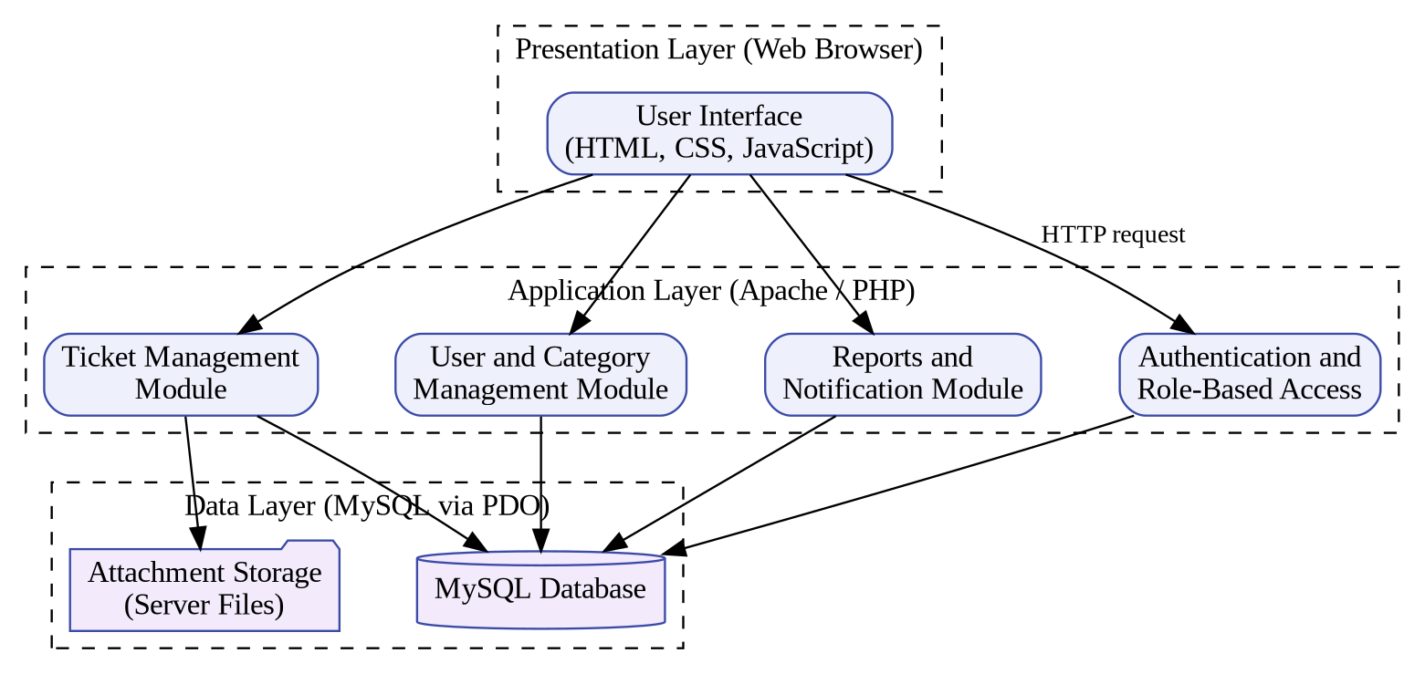
Figure 2: System Architecture of Ticketflow

3.6 Use Case Diagram
Figure 3 shows the actors of the system and the main functions available to each. The User, Support Staff, and Administrator all register or log in, after which each actor can perform only the functions of their own role.
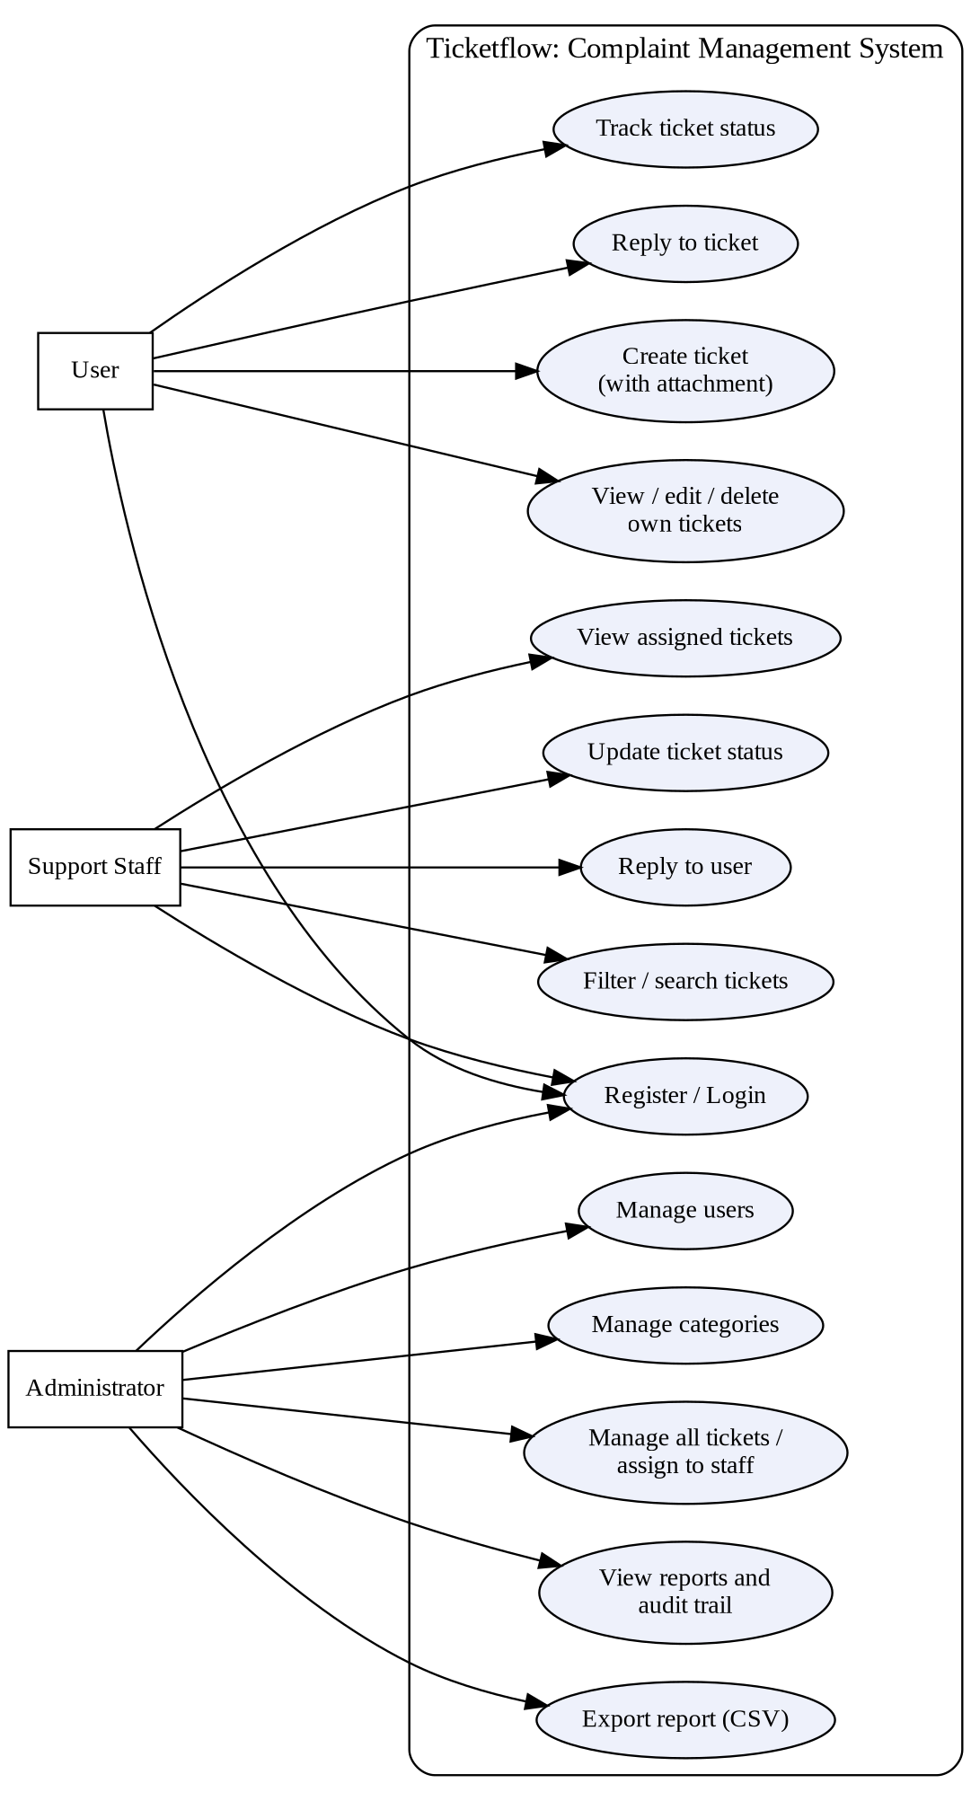
Figure 3: Use Case Diagram of Ticketflow

3.7 Use Case Description
Tables 3 to 5 describe three important use cases in detail.
Table 3: Use Case Description: Create Ticket
Item | Description
Use case name | Create Ticket
Actor | User
Precondition | The user is logged in.
Main flow | 1. The user selects "Create Ticket".  2. The user enters the subject, selects a category and priority, and writes the description.  3. The user optionally attaches a file.  4. The user clicks "Submit Ticket".  5. The system saves the ticket with a ticket number and shows it in the user's ticket list.
Alternative flow | If a required field is empty, the ticket is not submitted. The user can click "Cancel" to leave the form.
Postcondition | The ticket is stored and is visible to the user and the administrator.

Table 4: Use Case Description: Update Ticket Status
Item | Description
Use case name | Update Ticket Status
Actor | Support Staff
Precondition | The staff member is logged in and a ticket is assigned to them.
Main flow | 1. The staff member opens "Assigned Tickets".  2. The staff member searches or filters the list if required.  3. The staff member clicks "Manage" on a ticket.  4. The staff member updates the status and/or replies to the user.  5. The system records the change.
Postcondition | The new status is shown to the user and the action appears in the audit trail.

Table 5: Use Case Description: Manage Users
Item | Description
Use case name | Manage Users
Actor | Administrator
Precondition | The administrator is logged in.
Main flow | 1. The administrator opens "Manage Users" to see the User Directory.  2. The administrator searches by name or e-mail or filters by role.  3. The administrator clicks "Add New User" or "Edit User".  4. The administrator saves the user details and role.
Postcondition | The user directory shows the updated user, role, and account status.

3.8 Data Flow Diagrams

3.8.1 Context-Level DFD (Level 0)
Figure 4 shows the system as a single process interacting with three external entities: the User, the Support Staff, and the Administrator.
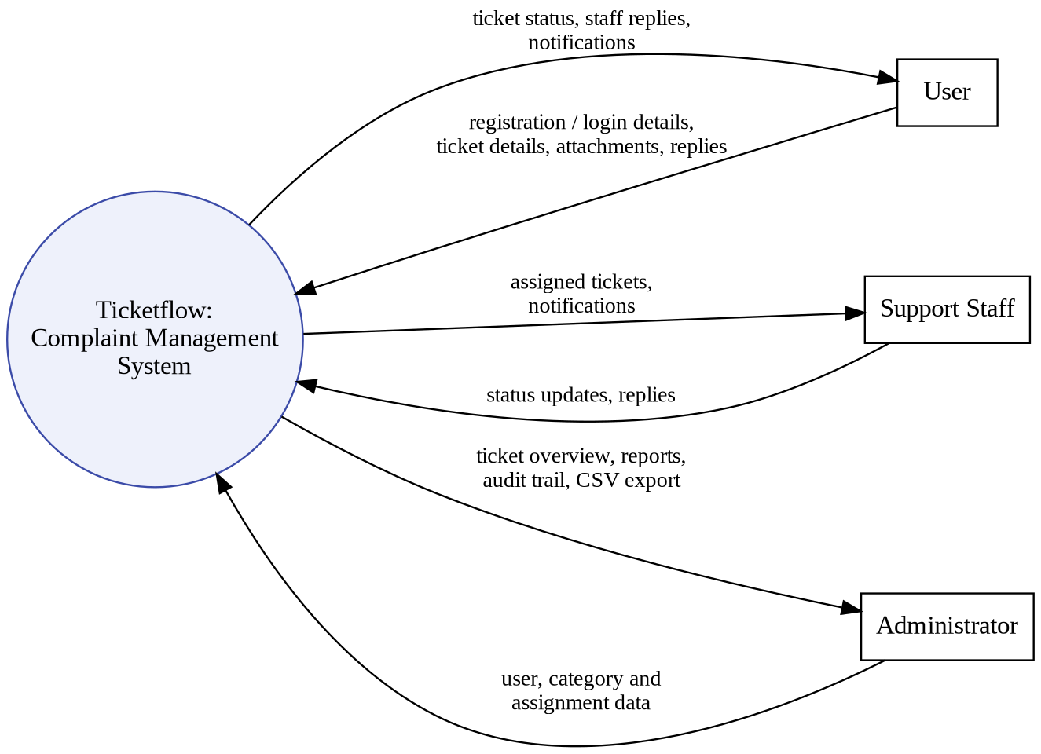
Figure 4: Context-Level DFD (Level 0) of Ticketflow

3.8.2 Level 1 DFD
Figure 5 expands the system into five processes: authentication, ticket submission, ticket processing, user and category management, and reporting with the audit trail. The data stores are Users, Categories, Tickets, and Replies / Activity Log.
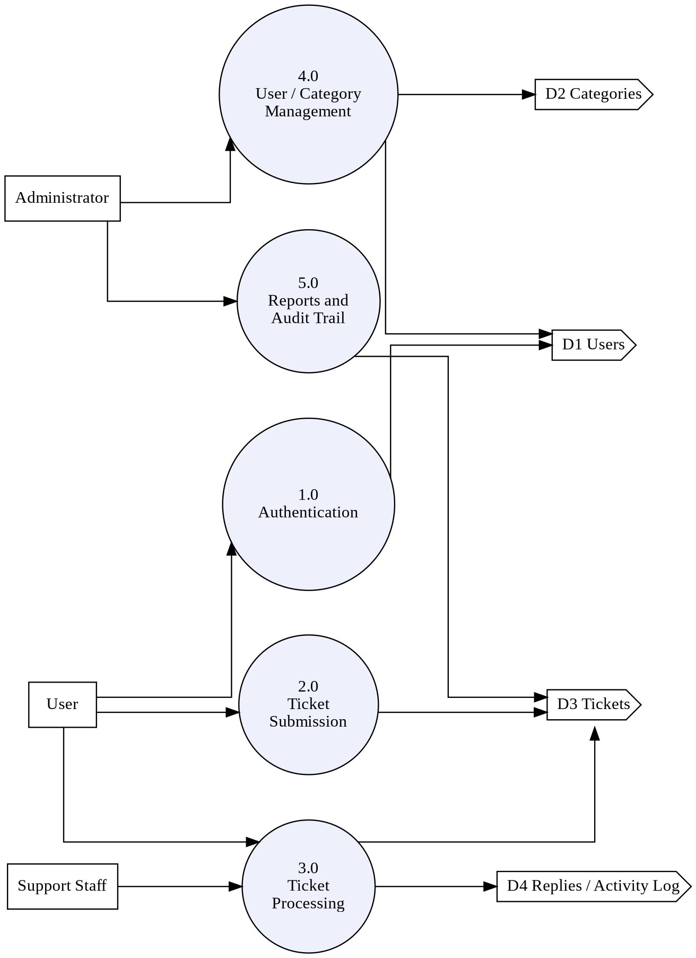
Figure 5: Level 1 DFD of Ticketflow

3.9 Entity Relationship Diagram
Figure 6 shows the relationships between the tables of the database, as defined in the database script. A user creates many tickets (tickets.user_id), and a ticket may be assigned to one staff user (tickets.assigned_to, which may be empty). Each ticket belongs to one category (tickets.category_id). A ticket has many messages (ticket_messages), many history entries (ticket_history), and many attachments (ticket_attachments); each of these records also refers to the user who sent, performed, or uploaded it. A user receives many notifications, and a notification may refer to a ticket.
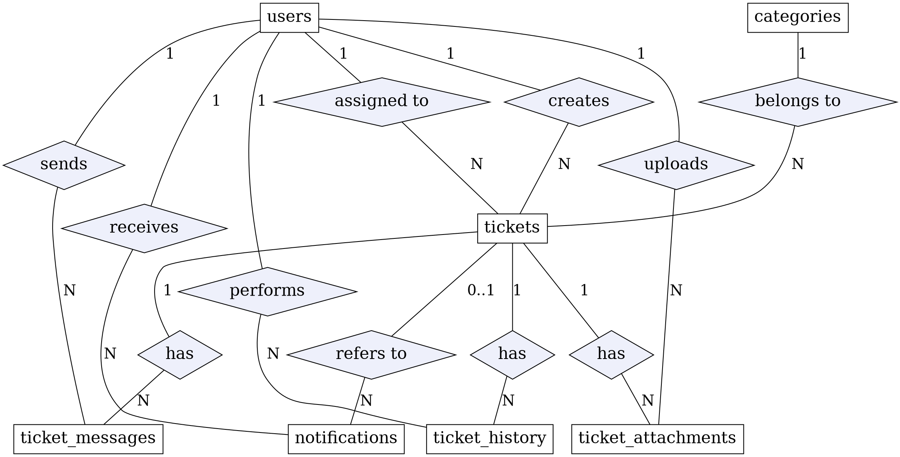
Figure 6: Conceptual ER Diagram of Ticketflow
The diagram was prepared from the database script (ticket_management_system.sql) and the later migration script (phase11_migration.sql). In the diagram, the replies of a ticket are stored in the table ticket_messages and the activity log (audit trail) is stored in the table ticket_history.

3.10 Database Design
The system stores its data in a MySQL relational database, which organizes data into related tables [4]. Table 6 lists the tables of the database and the information each one holds. The complete column definitions of the two main tables are given in Tables 7 and 8.
Table 6: Database Tables and Their Attributes
Entity | Columns | Purpose
users | id, name, e-mail, password (hashed), role (user / staff / admin), phone (optional), status (active / inactive), created_at, updated_at | Stores registered persons and their roles
categories | id, name, description, status (active / inactive), created_at | Classifies tickets (e.g., Technical Issue, Hardware Issue, Software Issue, Account Issue, Payment Issue, General Inquiry)
tickets | id, ticket_number, user_id (client), assigned_to (staff), category_id, subject, description, priority, status, created_at, updated_at, resolved_at, closed_at | Stores each complaint
ticket_messages | id, ticket_id, sender_id, message, is_internal, created_at | Stores replies and communication on a ticket
ticket_history | id, ticket_id, user_id, action, old_value, new_value, created_at | Records actions on tickets (audit trail)
ticket_attachments | id, ticket_id, user_id, file_name, original_name, file_path, file_type, file_size, created_at | Stores the details of files attached to tickets
notifications | id, user_id, ticket_id (optional), title, message, type, is_read, created_at | Informs users of ticket activity

Tables 7 and 8 give the data dictionary of the users and tickets tables as defined in the database script. The other tables follow the same conventions: an auto-incremented integer primary key named id, a created_at timestamp that defaults to the current time, and foreign keys to users and tickets that delete the dependent records when the parent record is deleted (ON DELETE CASCADE), except tickets.assigned_to, which is set to empty (ON DELETE SET NULL) when the assigned staff user is deleted.
Table 7: Data Dictionary: Users Table
Attribute | Data Type | Key | Description
id | INT, AUTO_INCREMENT | PK | Unique identifier of the user
name | VARCHAR(100), NOT NULL | — | Full name of the person
email | VARCHAR(100), NOT NULL | UK | Login e-mail address (unique)
password | VARCHAR(255), NOT NULL | — | Hashed account password
role | ENUM('user','staff','admin') | — | Role of the person; default 'user'
phone | VARCHAR(20) | — | Optional contact number
status | ENUM('active','inactive') | — | Account status; default 'active'
created_at | TIMESTAMP | — | Date and time the account was created
updated_at | TIMESTAMP | — | Date and time of the last update (automatic)

Table 8: Data Dictionary: Tickets Table
Attribute | Data Type | Key | Description
id | INT, AUTO_INCREMENT | PK | Unique identifier of the ticket
ticket_number | VARCHAR(50), NOT NULL | UK | Identifier shown to users (e.g., TKT-2026-00001)
user_id | INT, NOT NULL | FK → users(id) | User who created the ticket (client)
assigned_to | INT, NULL | FK → users(id) | Staff user the ticket is assigned to (may be empty)
category_id | INT, NOT NULL | FK → categories(id) | Category of the ticket
subject | VARCHAR(255), NOT NULL | — | Short summary of the complaint
description | TEXT, NOT NULL | — | Detailed description of the problem
priority | ENUM('LOW','MEDIUM','HIGH','URGENT') | — | Urgency of the ticket; default 'LOW'
status | ENUM('NEW','OPEN','ASSIGNED','IN PROGRESS','RESOLVED','CLOSED','REOPENED') | — | Current status; default 'NEW'
created_at / updated_at | TIMESTAMP | — | Creation time and last update time
resolved_at / closed_at | TIMESTAMP, NULL | — | Time the ticket was resolved or closed (empty until then)

3.11 System Flowchart
Figure 7 shows the overall flow of the system from login to logout. After successful authentication the system opens the dashboard that matches the role of the person.
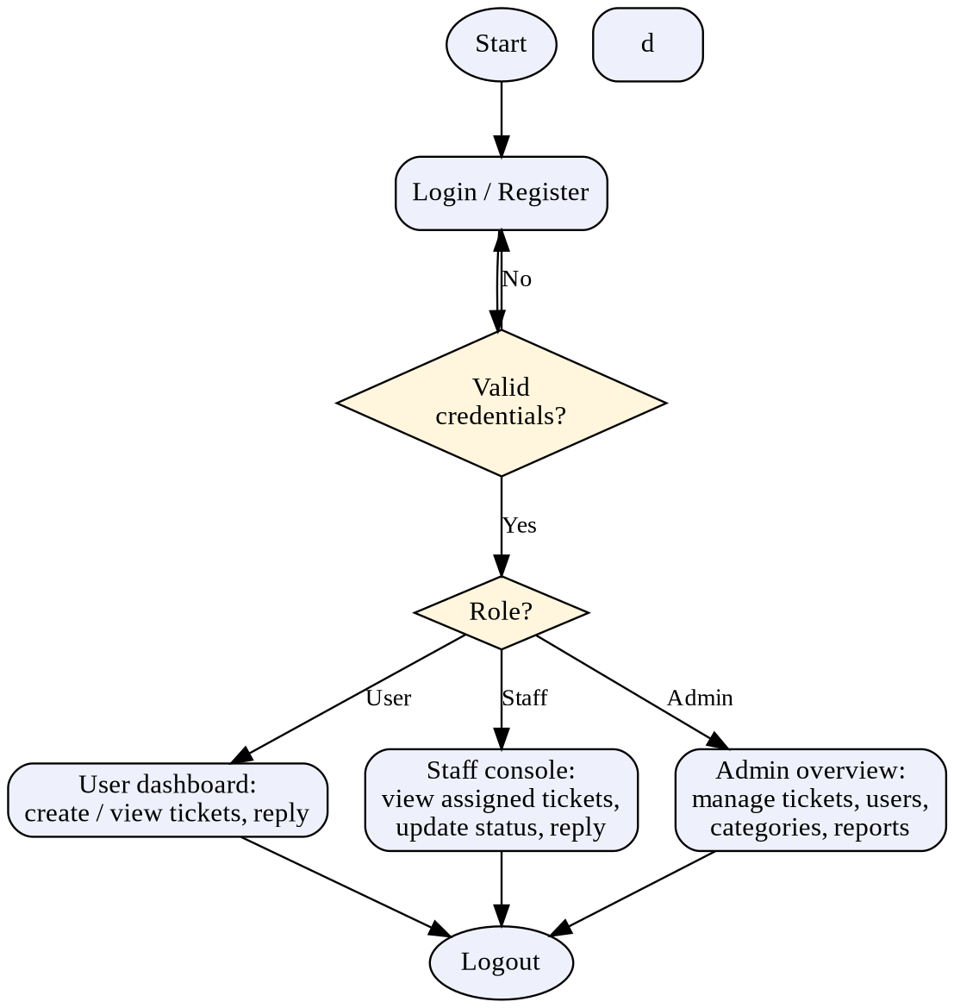
Figure 7: System Flowchart of Ticketflow

3.12 Ticket Status Lifecycle
A ticket passes through the statuses shown in Figure 8. The statuses New, Open, In Progress, Resolved, and Closed are the ones displayed in the reporting page of the system. The database also defines the statuses Assigned and Reopened (Table 8).
Figure 8: Ticket Status Lifecycle

CHAPTER 4: SYSTEM IMPLEMENTATION

4.1 Implementation Overview
Implementation is the stage where the designs of Chapter 3 are converted into working code. The system was implemented module by module: authentication first, then the user module, the staff module, and finally the administrator module with reports.

4.2 Development Environment
Table 9: Development Environment
Component | Details
Local server package | XAMPP (Apache web server)
Server-side language | PHP
Database | MySQL, accessed through PDO
Front-end | HTML, CSS, JavaScript
Testing browser | [PLACEHOLDER — INFORMATION REQUIRED: browser name and version]
Code editor | [PLACEHOLDER — INFORMATION REQUIRED: editor used]
Operating system | [PLACEHOLDER — INFORMATION REQUIRED]

4.3 Technologies Used
HTML (Hyper Text Markup Language) is used to structure the pages, including the forms, tables, and navigation. CSS (Cascading Style Sheets) is used for the layout, colors, status and priority badges, cards, and the light/dark appearance. JavaScript is used for client-side behavior such as showing or hiding the password, the sidebar collapse button, the theme toggle, and the file selection area on the ticket form [7].
PHP is a server-side scripting language used to process form submissions, apply the rules of each role, and generate the pages dynamically [5]. MySQL is an open-source relational database management system that stores users, categories, tickets, and related records [6]. PDO (PHP Data Objects) is used by the PHP scripts to communicate with the MySQL database.

4.4 Front-End Implementation
All screens share one layout: a sidebar on the left with the Ticket Flow logo and role-specific menu items, a top bar with a breadcrumb trail, a theme toggle, a notification bell, and the name and role badge of the logged-in person. Counts are displayed as cards, lists are displayed as tables, and statuses and priorities are displayed as colored badges (for example, URGENT in red and RESOLVED in green) so that they can be recognized quickly. The login and registration pages use a centered card design.

4.5 Back-End Implementation
The back end is written in PHP. The scripts receive the data submitted from the forms, communicate with the MySQL database through PDO, and return the pages for the logged-in role. The same ticket data is presented differently to each role: the user sees their own tickets, the staff member sees the tickets assigned to them, and the administrator sees all tickets.

4.6 Database Implementation
The data of the system is stored in a MySQL database named ticket_management_system, which contains the tables users, categories, tickets, ticket_messages, ticket_history, ticket_attachments, and notifications, as described in Section 3.10. The ticket_attachments table and the is_internal column of ticket_messages were added by a later migration script (phase11_migration.sql). Ticket numbers follow a format such as TKT-2026-00001, which includes the year and a running number.
The database is created by the script ticket_management_system.sql, which also inserts six demonstration categories (Technical Issue, Hardware Issue, Software Issue, Account Issue, Payment Issue, and General Inquiry) and three demonstration accounts, one for each role (admin, staff, and user).

4.7 Authentication and Authorization
A person logs in with an e-mail address and password on the "Welcome Back" page (Figure 9). A new person can create an account on the "Create an Account" page (Figure 10), where the full name, e-mail address, and password are required and the phone number is optional. After login, the dashboard and the sidebar menu depend on the role (User, Staff, or Admin), so that, for example, only the administrator sees the "Manage Users", "Categories", and "Reports" menu items.
The password column of the users table is VARCHAR(255), and the demonstration accounts in the database script store their passwords as bcrypt hashes (the "$2y$10$" prefix) rather than as plain text. The role of each person is stored in the role column (user, staff, or admin).

4.8 User Module
The user module provides the dashboard, "Create Ticket", "My Tickets", and "Profile" pages. The dashboard shows the user's total, open/pending, in-progress, and resolved tickets and a "Recent Tickets" table. From this table the user can view, edit, or delete a ticket. The ticket creation form requires a subject, category, priority, and description, and accepts an optional attachment.

4.9 Staff Module
The staff module provides the "Support Staff Console" dashboard, the "Assigned Tickets" page, and the profile page. The dashboard shows counts of new/assigned, in-progress, resolved, and active high-priority tickets and a table of active assigned tickets. The "Assigned Tickets" page allows searching by ticket number, subject, or client and filtering by status, priority, and category. Each ticket has a "Manage" action.

4.10 Administrator Module
The administrator module provides the "System Administration Overview" dashboard, "All Tickets", "Manage Users", "Categories", "Reports", and "Profile". The dashboard shows system metrics, recent tickets with their assigned staff member, and the recent audit trail. "Manage Users" shows a User Directory in which users can be searched, filtered by role, added, and edited.

4.11 Ticket Management
Each ticket has a ticket number, subject, category, priority (Low, Medium, High, Urgent), description, status, client, and assigned staff member. Tickets that have not been assigned are shown as "Unassigned" in the administrator's list. Users can edit or delete their own tickets from the dashboard list. Status changes and replies are recorded and shown in the audit trail.

4.12 Category Management
Categories are used to classify tickets when they are created and to filter tickets in the staff and report pages. The reporting page of the implemented system shows the categories Technical Issue, Hardware Issue, General Inquiry, Software Issue, and Payment Issue. Here "Payment Issue" is only a category name for complaints; the system does not process payments. Administrators manage the categories from the "Categories" menu.

4.13 Replies and Communication
Users and administrators can reply on a ticket, and these replies appear in the audit trail with the sender, the ticket number, and the time (for example, "User replied" and "Admin replied"). This keeps the communication about a complaint attached to the complaint itself.

4.14 Notification System
A bell icon in the top bar shows a notification indicator. In the staff screens, a badge with a count is displayed on the bell when there are notifications for the staff member (Figures 13 and 14). Notifications are shown inside the application only.

4.15 Attachment Handling
On the ticket form, the user can click to browse or drag and drop a file. The form states the supported types (JPG, PNG, GIF, WEBP, PDF, DOC, DOCX, XLS, XLSX, and TXT) and a maximum size of 5 MB. The details of an attached file (original name, stored name, path, type, and size) are stored in the ticket_attachments table, which is linked to the ticket and to the user who uploaded the file.

4.16 Reports and Audit Trail
The administrator's "Reporting & Analytics" page provides filters for time, status, priority, category, and staff; summary cards for total tickets, resolved/closed tickets, active tickets, high/urgent tickets, resolution rate, and average resolution time; breakdown panels for ticket status, priority, and category; a staff workload and performance table; and totals of registered users and support staff. The "Export CSV" button is provided to export the report. The audit trail on the administrator dashboard lists recent actions on tickets.

4.17 Display Mode and Responsive Layout
A moon-icon button in the top bar allows the display mode to be switched, and the sidebar can be collapsed with the arrow button beside the logo. The layout uses flexible cards and tables so that it can adapt to different screen sizes.
[PLACEHOLDER — INFORMATION REQUIRED: if you want to claim mobile responsiveness, add a mobile screenshot and test result; none was supplied for this report.]

CHAPTER 5: SYSTEM TESTING

5.1 Introduction
Testing checks whether the system behaves according to its requirements and helps to find errors before the system is used. This chapter describes the testing strategy and the test cases prepared for the system.

5.2 Testing Strategy
Three levels of testing were planned. Functional testing checks each function on its own, such as logging in or creating a ticket. Integration testing checks that the modules work together, for example that a ticket created by a user appears in the staff and administrator screens. System testing checks the complete system from the point of view of the three roles.

5.3 Test Environment
The tests were carried out on the local development environment described in Section 4.2: the XAMPP Apache server, PHP, and MySQL, accessed through a web browser. Sample accounts for the User, Staff, and Admin roles and a small number of sample tickets were used.

5.4 Test Cases
The test cases are given in Tables 10 to 13. In the "Actual Result" column, a result is recorded only where it is supported by the interface screenshots of Chapter 6. Test cases whose results have not yet been recorded are marked "Pending" so that they can be executed and completed before submission.
Table 10: Test Cases: Authentication and Registration
ID | Test Scenario | Input | Expected Result | Actual Result | Status
TC-01 | Admin logs in with valid credentials | Valid admin e-mail and password | Administration overview opens | Administration overview displayed (Figure 15) | Pass
TC-02 | Login with wrong password | Valid e-mail, wrong password | Error message; user stays on login page | [To be recorded] | Pending
TC-03 | Login with empty fields | Blank e-mail and password | Required-field message | [To be recorded] | Pending
TC-04 | Registration form shows required fields | Open "Create an Account" | Full name, e-mail, password, and confirm password marked required; phone optional | Form displayed as expected (Figure 10) | Pass
TC-05 | Register with mismatched passwords | Password and confirm password differ | Account not created; message shown | [To be recorded] | Pending
TC-06 | User logs in | Valid user account | User dashboard opens with welcome message | User dashboard displayed (Figure 11) | Pass
TC-07 | Staff logs in | Valid staff account | Support Staff Console opens | Staff console displayed (Figure 13) | Pass

Table 11: Test Cases: Ticket Management
ID | Test Scenario | Input | Expected Result | Actual Result | Status
TC-08 | Create-ticket form displays | Click "Create Ticket" | Form with subject, category, priority, description, and attachment area | Form displayed (Figure 12) | Pass
TC-09 | Submit a valid ticket | Subject, category, priority, and description entered | Ticket saved with a ticket number and listed on the dashboard | Tickets with numbers listed (Figure 11) | Pass
TC-10 | Submit ticket with empty required field | Blank subject | Ticket not submitted; message shown | [To be recorded] | Pending
TC-11 | Upload file larger than 5 MB | File over 5 MB | File rejected | [To be recorded] | Pending
TC-12 | Ticket list shows status and priority | Open user dashboard | Each ticket shows status and priority badges | Badges displayed (Figure 11) | Pass
TC-13 | Edit a ticket description | Click "Edit", change description | Change saved and logged | Audit trail shows "Description updated" (Figure 15) | Pass
TC-14 | Delete a ticket | Click "Delete" | Ticket removed after action | [To be recorded] | Pending
TC-15 | Reply on a ticket | User and admin send replies | Replies recorded with sender and time | Replies shown in audit trail (Figure 15) | Pass

Table 12: Test Cases: Staff and Administrator Functions
ID | Test Scenario | Input | Expected Result | Actual Result | Status
TC-16 | Staff sees assigned tickets | Open "Assigned Tickets" | Only tickets assigned to the staff member are listed | Two assigned tickets listed (Figure 14) | Pass
TC-17 | Staff filters tickets by status | Select a status and click "Filter" | List shows matching tickets only | [To be recorded] | Pending
TC-18 | Staff notification badge | Staff logs in with unread notification | Count badge shown on bell | Badge "1" displayed (Figures 13, 14) | Pass
TC-19 | Status change is recorded | Status of a ticket changed | Change visible in audit trail | Audit trail shows "Status changed" (Figure 15) | Pass
TC-20 | Admin dashboard statistics | Open administrator dashboard | Totals, recent tickets, and audit trail displayed | Displayed as expected (Figure 15) | Pass
TC-21 | User directory lists users | Open "Manage Users" | Users listed with role, status, and joined date | Directory displayed (Figure 16) | Pass
TC-22 | Search and filter users | Enter name or select role, click "Filter" | Matching users listed | [To be recorded] | Pending
TC-23 | Add a new user | Click "Add New User" and save | User appears in directory | [To be recorded] | Pending
TC-24 | Reports page displays | Open "Reports" | Summary cards, breakdowns, and workload table displayed | Displayed as expected (Figure 17) | Pass
TC-25 | Export report as CSV | Click "Export CSV" | CSV file downloaded | [To be recorded] | Pending

Table 13: Integration and System Test Cases
ID | Test Scenario | Input | Expected Result | Actual Result | Status
IT-01 | Ticket visible across roles | Ticket TKT-2026-00001 created by a user | Ticket appears for the user, the assigned staff member, and the administrator | Ticket appears in Figures 11, 14, and 15 | Pass
IT-02 | Status consistent across roles | Ticket with status "In Progress" | Same status displayed in all three role screens | Status "In Progress" displayed in Figures 11, 14, and 15 | Pass
ST-01 | Totals agree with ticket data | Three tickets in the system | Administrator total equals the sum of all users' tickets | Total of 3 shown in Figures 15 and 17 | Pass

5.5 Functional Testing
Functional testing covers the test cases TC-01 to TC-25. The login, registration form, ticket form, ticket list, reply recording, assigned-ticket list, notification badge, administrator dashboard, user directory, and reports page were verified from the working interface. Negative cases such as invalid input, file size limits, deletion, filtering, and CSV export remain to be executed and recorded.

5.6 Integration Testing
Integration test IT-01 and IT-02 verify that the same ticket data is presented consistently in the user, staff, and administrator modules. A ticket created by a user (TKT-2026-00001, subject "internet issues") appears in the user's dashboard, in the assigned-ticket queue of the support staff, and in the administrator's recent tickets with the same status.

5.7 System Testing
System test ST-01 checks that the totals are consistent. The administrator dashboard and the reports page both show three tickets in total, which matches the two tickets of one user and the one ticket of another user.

5.8 User Acceptance Testing
[PLACEHOLDER — INFORMATION REQUIRED: if user acceptance testing was carried out with real users, record the participants and their feedback here. No UAT results were supplied.]

5.9 Test Results
Table 14: Summary of Test Results
Total test cases | Passed | Pending
28 | 18 | 10

Of the 28 test cases prepared, 18 have been verified against the working system and passed, and 10 are pending execution. No failed test case is recorded in this report.

5.10 Summary
The core functions of the three roles were verified through the working interface. The pending test cases should be executed and their results recorded before the final submission.

CHAPTER 6: RESULTS AND DISCUSSION

6.1 Introduction
This chapter presents the implemented system through screenshots of its actual interface. The screens are described in the order in which a person uses the system: login and registration, the user screens, the staff screens, and the administrator screens.

6.2 Login Interface
Figure 9 shows the login page. It displays the "Support Desk" label and the title "Welcome Back". The person enters an e-mail address and a password; the password is masked and an eye icon allows it to be shown. The "Sign In" button opens the dashboard of the person's role, and a link is provided to create an account.
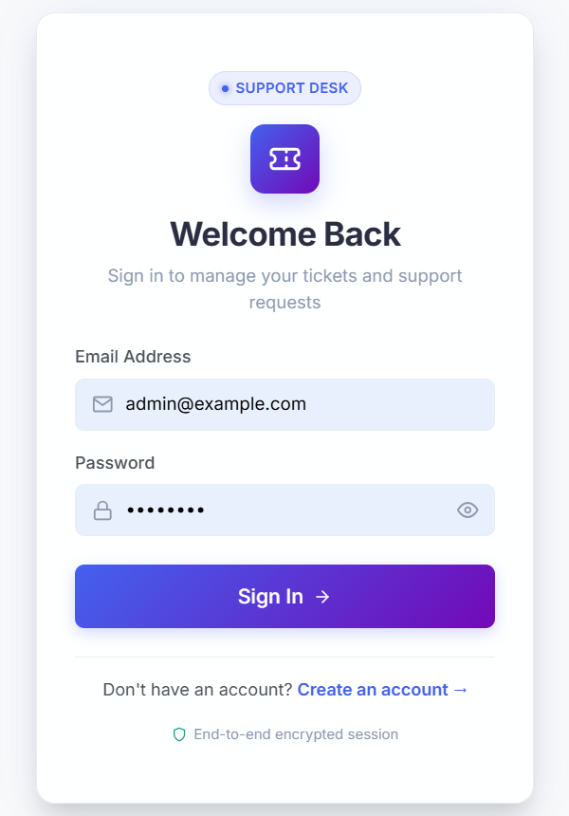
Figure 9: Login Interface

6.3 User Registration
Figure 10 shows the registration page. The new person enters a full name, an e-mail address, an optional phone number, a password, and a confirmation of the password. Required fields are marked with an asterisk, and a bar under the password field indicates password strength.
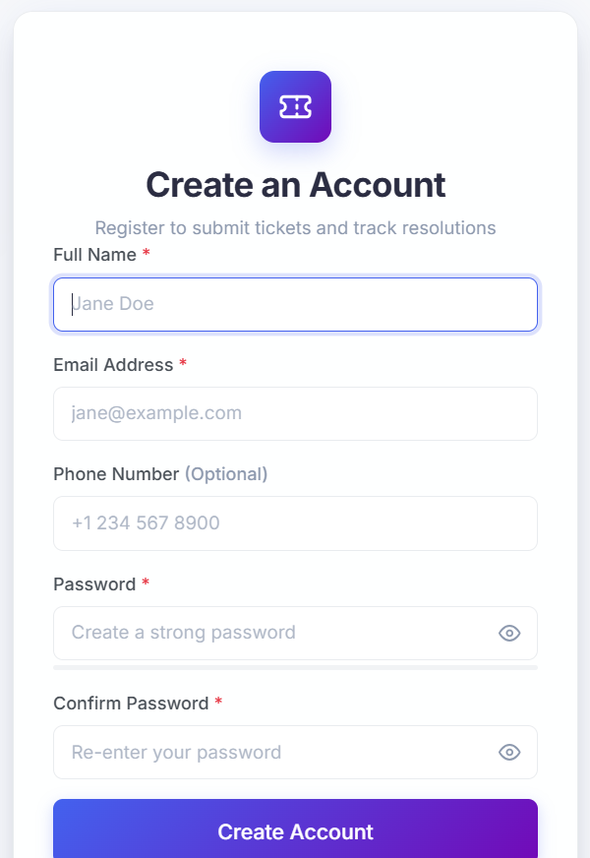
Figure 10: User Registration Interface

6.4 User Dashboard
Figure 11 shows the user dashboard after login. It greets the user by name and shows four cards: total tickets (2), open/pending (0), in progress (1), and resolved (1). The "Recent Tickets" table lists the ticket number, subject, status, priority, and creation date, with View, Edit, and Delete actions. The "Create New Ticket" button opens the ticket form.
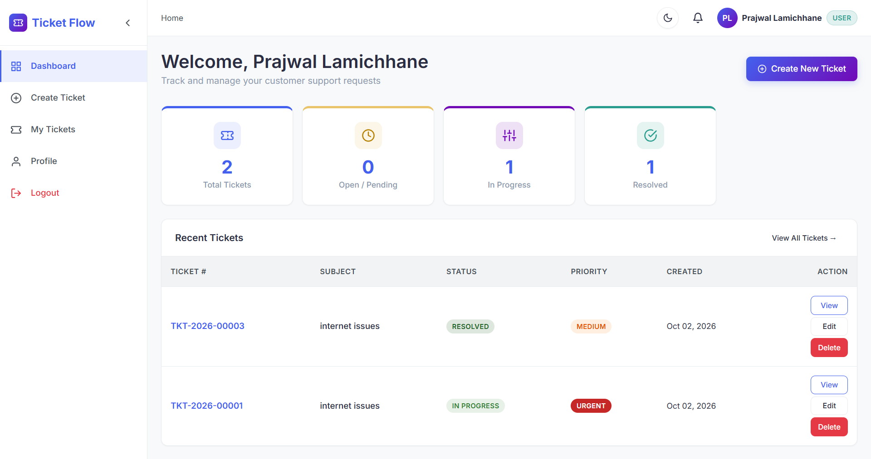
Figure 11: User Dashboard

6.5 Ticket Creation
Figure 12 shows the "Submit a Support Ticket" page. The user enters the ticket subject, selects a category, chooses a priority (Low, Medium, High, or Urgent), and writes a detailed description. An optional attachment of up to 5 MB can be added by browsing or by drag and drop. The ticket is saved with the "Submit Ticket" button, or the form is left with "Cancel".
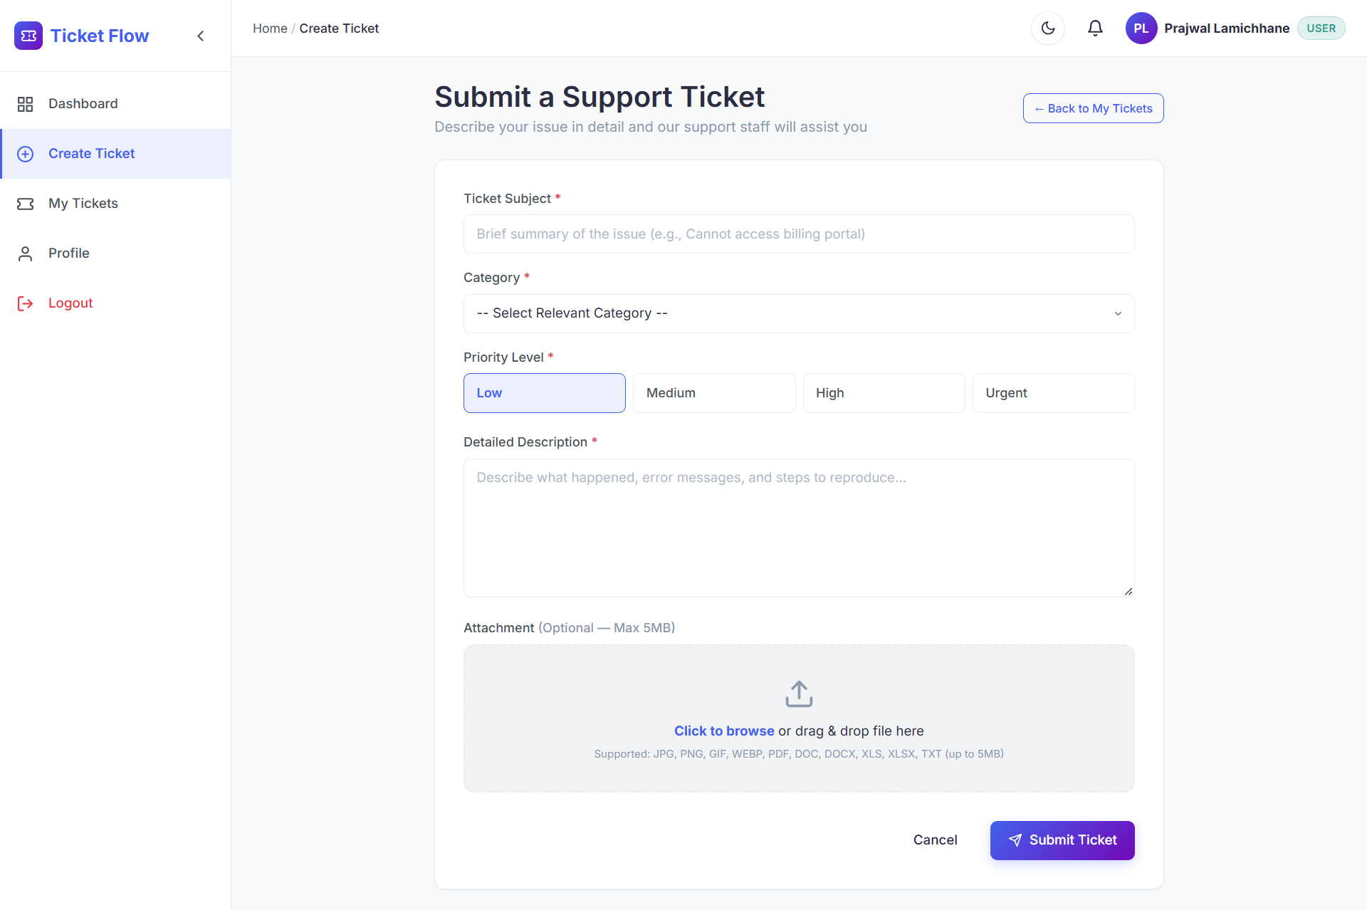
Figure 12: Ticket Creation Interface

6.6 Staff Dashboard
Figure 13 shows the Support Staff Console. Its cards show one new/assigned ticket, one in-progress ticket, no resolved ticket, and one active high-priority ticket. The table "Active Assigned Tickets" lists the ticket number, subject, client, status, and priority with a "Manage" action. The badge on the bell icon shows that there is a notification.
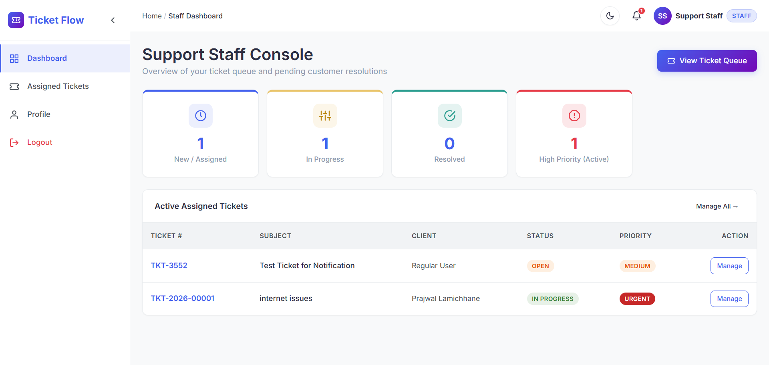
Figure 13: Support Staff Dashboard

6.7 Assigned Tickets
Figure 14 shows the "Assigned Tickets" page of the staff member. The search box and the status, priority, and category filters help the staff member to find tickets in the queue. The table shows the ticket number, subject, client, priority, status, and last updated time, and the "Manage" button opens a ticket for handling.
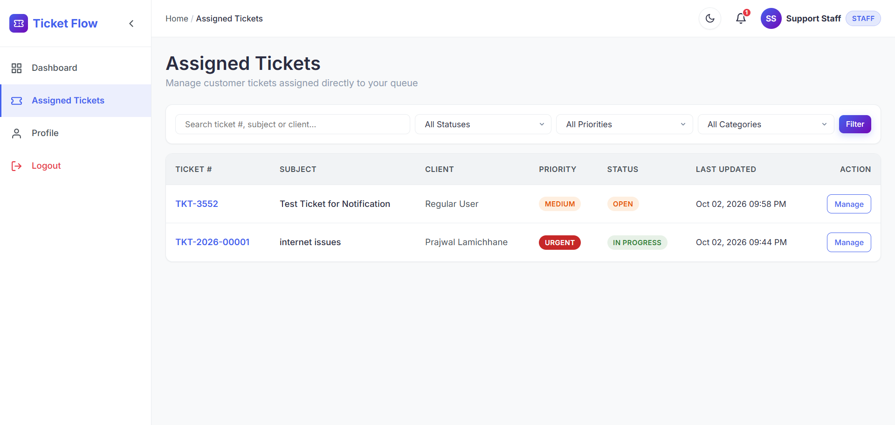
Figure 14: Assigned Tickets Interface of Support Staff

6.8 Administrator Dashboard
Figure 15 shows the "System Administration Overview". Its cards show 3 total tickets, 1 new/open, 1 in progress, 1 urgent/high priority, 5 registered clients, and 1 support agent. The "Recent Tickets" table shows the client and assigned staff member of each ticket (or "Unassigned"), and the "Recent Audit Trail" lists recent actions such as status changes, replies, and description updates with the time of each action.
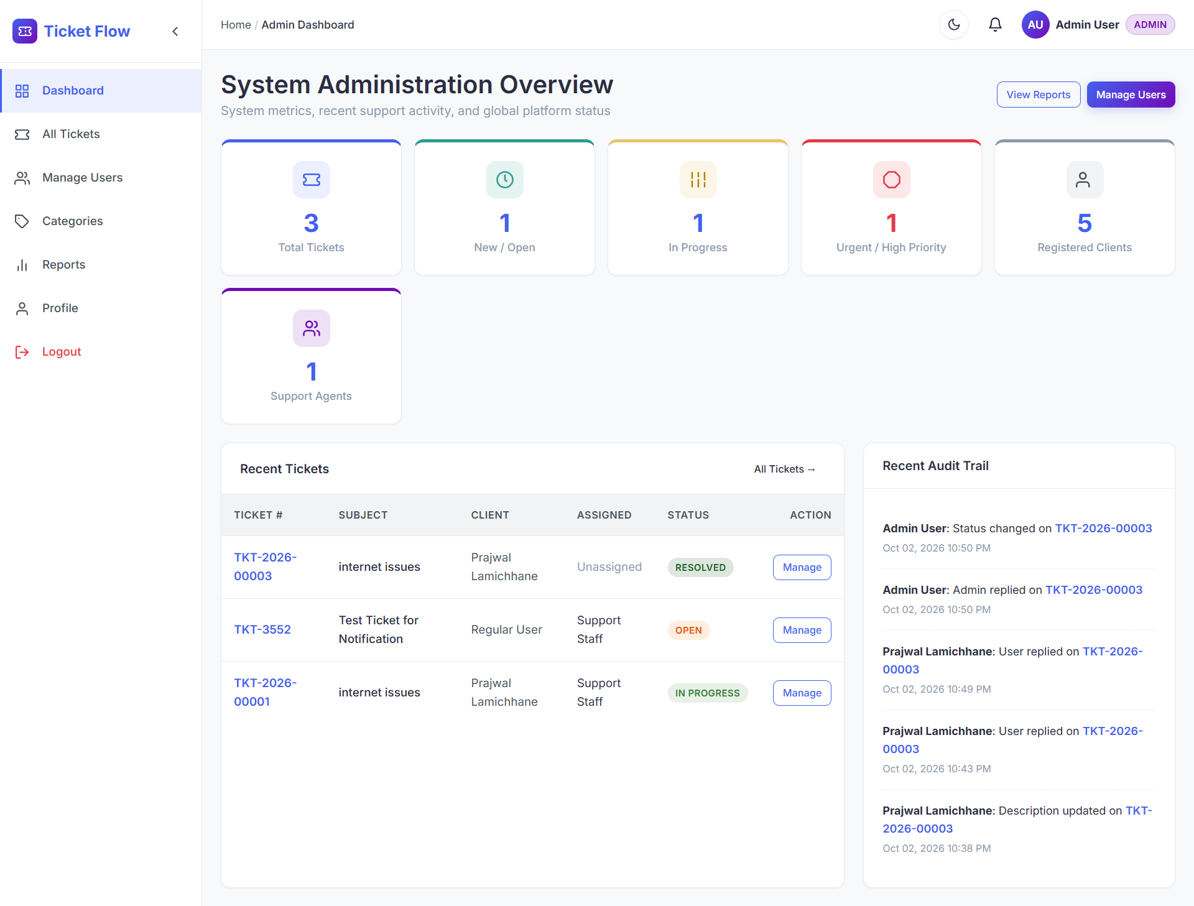
Figure 15: Administrator Dashboard

6.9 User Management
Figure 16 shows the User Directory. The administrator can search by name or e-mail, filter by role, and add a new user. The table lists each user's name, e-mail address, phone number, system role (USER, STAFF, or ADMIN), account status, joined date, and an "Edit User" action.
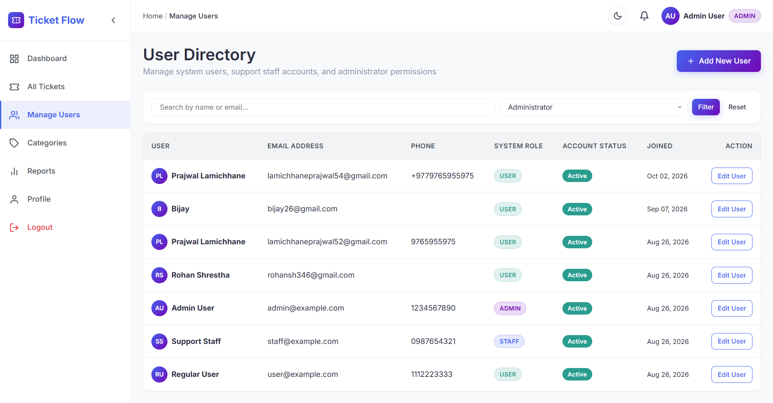
Figure 16: User Management Interface of Administrator

6.10 Reporting and Analytics
Figure 17 shows the reporting page. The filter bar allows the report to be limited by time, status, priority, category, and staff. The cards show 3 total tickets, 1 resolved/closed, 2 active, 1 high/urgent, a resolution rate of 33.3%, and an average resolution time of "N/A" because there is not yet enough resolution data. The panels show ticket counts by status, priority, and category, followed by the staff workload table and the totals of 5 registered users and 1 support staff member. The "Export CSV" button exports the report.
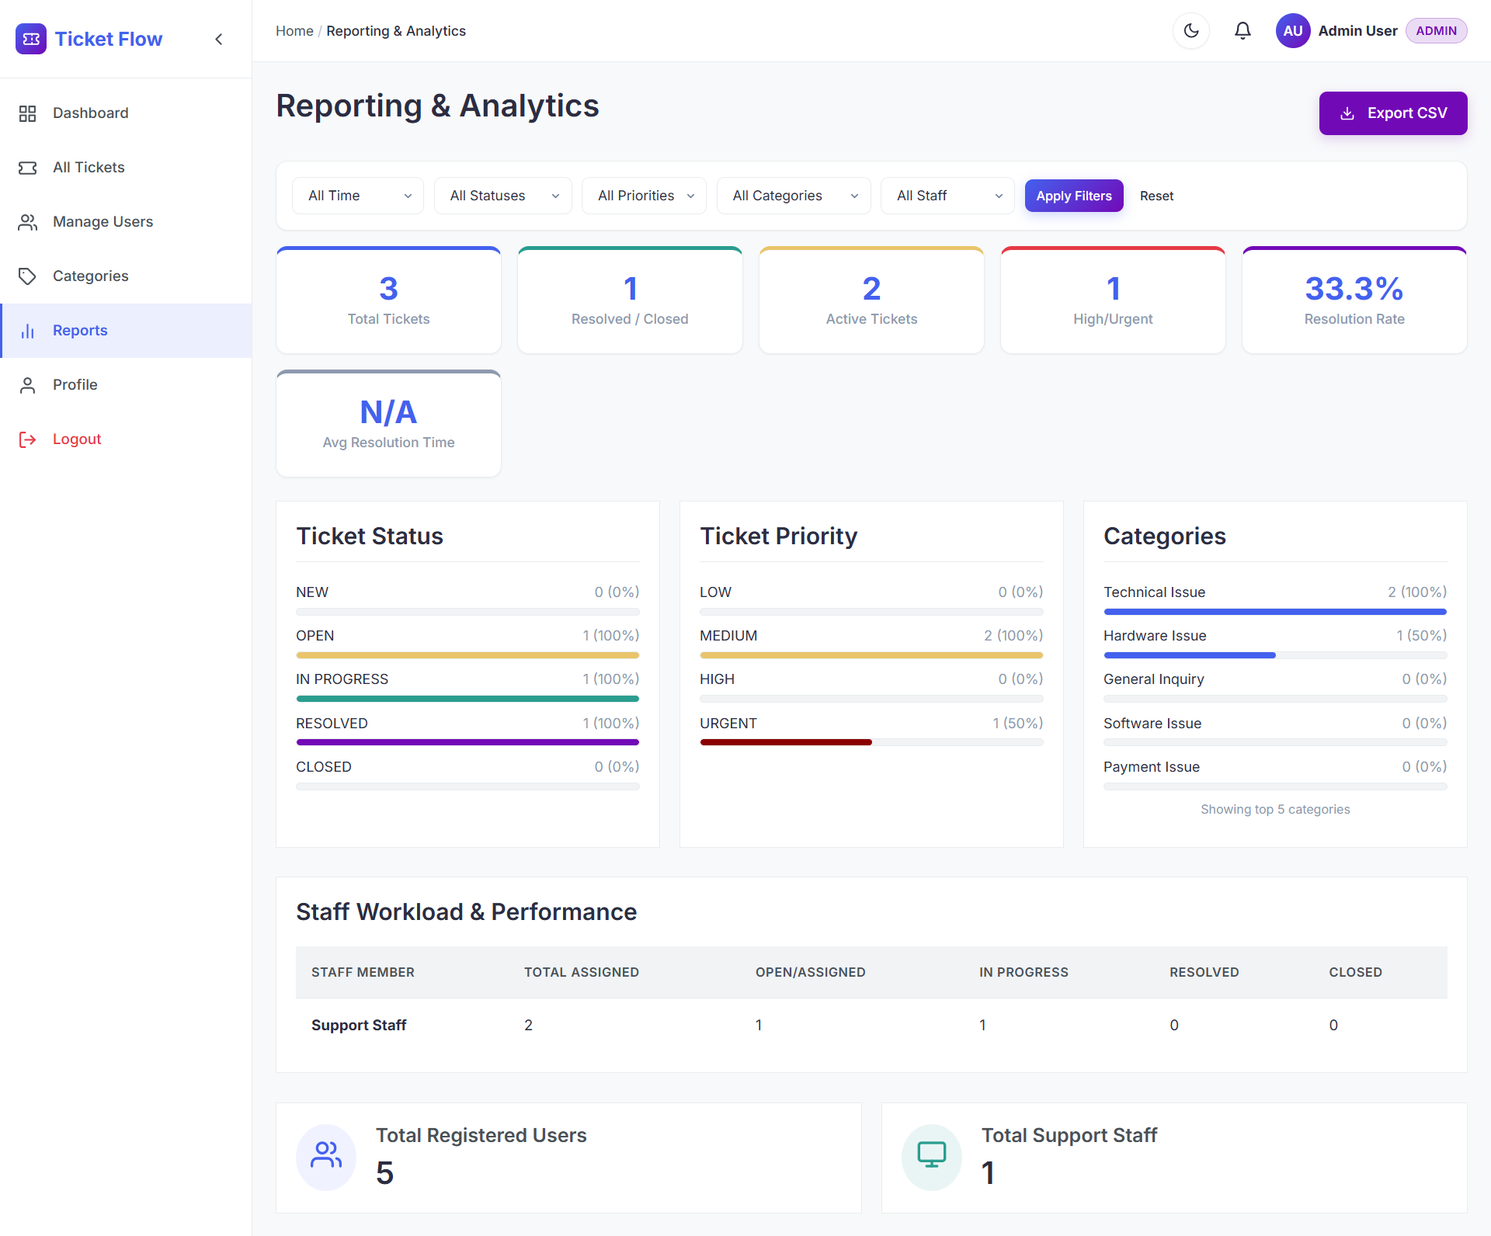
Figure 17: Reporting and Analytics Interface

6.11 Discussion of Results
The screenshots show that the three roles are served by separate dashboards and menus, and that the same ticket data is consistent across them. For example, the ticket "internet issues" (TKT-2026-00001) appears as In Progress with Urgent priority for the user, the support staff, and the administrator. The counts on the administrator dashboard (3 tickets, 1 in progress, 1 urgent/high) agree with the counts of the reports page.
The reports page gives the administrator a quick summary of the ticket flow. The resolution rate of 33.3% corresponds to one resolved ticket out of three. In the status, priority, and category panels, the percentage shown beside each count appears to be calculated relative to the largest group rather than to the total number of tickets (for example, one ticket each in Open, In Progress, and Resolved is shown as 100%). This display could be improved in a future version so that percentages are calculated from the total.
The results are based on a small set of sample data, so they demonstrate that the functions work but do not measure the performance of the system under heavy use.

CHAPTER 7: CONCLUSION AND FUTURE ENHANCEMENTS

7.1 Lessons Learnt
During the development of this project, the developer learned how to design a role-based web application, how to organize data in a relational database, and how to present the same data in different ways for different roles. The project also showed the importance of planning the ticket lifecycle (status and priority) before developing the screens, of testing each module before integrating it, and of documenting the system carefully.

7.2 Conclusion
Ticketflow: Complaint Management System provides a single platform on which complaints can be submitted, assigned, tracked, and resolved. Users can create tickets and follow their status, support staff can manage a queue of assigned tickets, and administrators can manage users, categories, and tickets, review an audit trail, and use a reporting page. The implemented screens and test results show that the main objectives of the project have been met on the sample data used. The system also has limitations, described in Section 1.4.2, that can be addressed in future work.

7.3 Future Enhancements
The following improvements are suggested as future work. They are not part of the current system.
- E-mail, SMS, or push notifications in addition to the in-application notification indicator.
- A mobile application for submitting and tracking tickets.
- Graphical charts and more advanced analytics in the reports.
- Automatic classification and prioritization of complaints, for example using machine learning.
- Calculation of report percentages from the total number of tickets and tracking of average resolution time.
- Deployment on a cloud server to support a larger number of users.

REFERENCES
[1] I. Sommerville, Software Engineering, 10th ed. Harlow, U.K.: Pearson, 2016.
[2] R. S. Pressman and B. R. Maxim, Software Engineering: A Practitioner's Approach, 8th ed. New York, NY, USA: McGraw-Hill Education, 2014.
[3] K. Beck et al., "Manifesto for Agile Software Development," 2001. [Online]. Available: https://agilemanifesto.org
[4] R. Elmasri and S. B. Navathe, Fundamentals of Database Systems, 7th ed. Hoboken, NJ, USA: Pearson, 2016.
[5] The PHP Group, "PHP Manual." [Online]. Available: https://www.php.net/manual/en/
[6] Oracle Corporation, "MySQL Reference Manual." [Online]. Available: https://dev.mysql.com/doc/
[7] Mozilla, "MDN Web Docs." [Online]. Available: https://developer.mozilla.org/

APPENDIX A: SUPERVISOR LOG SHEET
Table 15: Supervisor Log Sheet
S.N. | Date | Work Done | Comments | Signature | Remarks
1
2
3
4
5

